Theories of Entrepreneurship

A coordinated and comprehensive theory of Entrepreneurship is yet to come. Mean while let’s try to understand the following theories of entrepreneurship propounded by the different eminent social thinkers:
- Innovation Theory of Schumpeter
- Need for Achievement Theory of McClelland
- Leibenstein’s X-efficiency Theory
- Risk Bearing Theory of knight.
- Max Weber’s Theory of Entrepreneurial Growth
- Hagen’s Theory of Entrepreneurship
- Thomas Cochran’s Theory of Cultural Values
- Theory of Change in Group Level Pattern
- Economic Theory of Entrepreneurship
- Exposure Theory of Entrepreneurship.
- Political System Theory for Entrepreneurial Growth.

Innovation Theory of Schumpeter:
A dynamic theory of entrepreneurship was first advocated by Schumpeter (1949) who considered entrepreneurship as the catalyst that disrupts the stationary circular flow of the economy and thereby initiates and sustains the process of development. Embarking upon ‘new combinations’ of the factors of production
- Which he succinctly terms, innovation - the entrepreneur activates the economy to a new level of development.

Schumpeter introduced a concept of innovation as key factor in entrepreneurship in addition to assuming risks and organising factor of production. Schumpeter defines entrepreneurship as “a creative activity”. An innovator who brings new products or services into economy is given the status of an entrepreneur. He regards innovation as a tool of entrepreneur, The entrepreneur is viewed as the ‘engine of growth’, He sees the opportunity for introducing new products, new markets, new sources of supply, new forms of industrial organization or for the development of newly discovered resources. The concept of innovation and its corollary development embraces five functions:
  - The introduction of a new product with which consumers are not yet familiar or introduction of a new quality of an existing product,
  - The introduction of new method of production that is not yet tested by experience in the branch of manufacture concerned, which need by no means be founded upon a discovery scientifically new and can also exist in a new way of handling a commodity commercially,
  - The opening of new market that is a market on to which the particular branch of manufacturer of the country in question has not previously entered, whether or not this market has existed before,
  - Conquest of a new source of supply of raw material and
  - The carrying out of the new organisation of any industry.
Schumpeter is the first major theorist to put the human agent at the centre of the process of economic development. He is very explicit about the economic function of the entrepreneur. The entrepreneur is the prime mover in economic development; his function, to innovate or carry out new combinations. Schumpeter makes a distinction between an innovator and an inventor. An inventor discovers new methods and new materials. On the contrary, an innovator is one who utilises or applies inventions and discoveries in order to make new combinations. An inventor is concerned with his technical work of invention whereas an entrepreneur converts the technical work into economic performance. An innovator is more than an inventor because he does not only originate as the inventor does but goes much farther in exploiting the invention commercially.

New Product New Method
Innovation
Innovation
New Market
New pply
Source of su Carries out a
Exploiting profitable business opportunities
new organization
Creativity
Entrepreneurship
Sustainable Economic Development

Figure 2.3: Innovation Theory of Entrepreneurship

Wilken had added the concept of the changes that an entrepreneur brings:
- Expansion of goods, products.
- Productivity of factors of production such as finance, labour, material.
- Innovation in production such as, technology, process changes and increase in human resource productivity.
- Innovation in marketing area such as the composition of the market, size of the market and new markets.
To Schumpeter, entrepreneurs are individuals motivated by a will for power; their special characteristic being an ­inherent capacity to select correct answers, energy, will and mind to overcome fixed talents of thoughts, and a capacity to withstand social opposition. The factors that contribute to the development of entrepreneurship would essentially be a suitable environment in grasping the essential facts.
It can be noted that this theory’s main figure, the “innovating entrepreneur” has played an important role in the rise of modem capitalism. The entrepreneur has been the prime mover - for economic development process. On the criticism side, this theory seems one-sided as it puts too much emphasis on innovative functions. It ignores the risk taking and organizing aspects of entrepreneurship. An entrepreneur has not only to innovate but also assemble the resources and put them to optimum use.
While stressing upon the innovative function of the entrepreneur, Schumpeter ignoredthe risk-taking function, which is equally important. When an entrepreneur develops a new combination of factors of production, there is enough risk involved.
In spite of these lacking, the theory supports the “enterprising spirit” of entrepreneur to innovate. It is the act that endows resources with a new capacity to create wealth. Drucker says, “Innovation, indeed, creates a resource. It endows it with economic value.” Schumpeter’s views are particularly relevant to developing countries where innovations need to be encouraged. The transformation of an agrarian economy into an industrial economy required a great deal of initiative and changes on the part of businessmen and managers.

Need for Achievement Theory of McClelland:
According to McClelland the characteristics of entrepreneur has two features - first doing things ina new and better way and second decision making under uncertainty. McClelland emphasises achievement orientation as most important factor for entrepreneurs. Individuals with high. achievement orientation are not influenced by considerations of money or any other external incentives. Profit and incentives are merely yardsticks of measurement of success of entrepreneurs with high achievement orientation. People withhigh achievement (N-Ach) are not influenced by money rewards as compared to people with low achievement. The latter types are prepared to work harder for money or such other external incentives. On the contrary, profit is merely a measure of success and competency for people with high achievement need.
Professor David McClelland, in his book The Achieving Society, has propounded a theory based on his research that entrepreneurship ultimately depends on motivation. It is the need for achievement (N-Ach), the sense of doing and getting things done, that promote entrepreneurship. According to him, N-Ach is a relatively stable personality characteristic rooted inexperiences in middle childhood through family socialisation and child-learning practices which stress standards of excellence, material warmth, self-reliance training and

low father dominance. According to him a person acquires three types of needs as a result of one’s life experience. These three needs are:
  - Need for Achievement. A drive to excel, advance and grow.
  - Need for Power. A drive to dominate or influence others and situations.
  - Need for Affiliation. A drive for friendly and close inter-personal relationships.
McClelland found that certain societies tended to produce a large percentage of people with high achievement. He pointed out that individuals, indeed whole societies that possess N-ach will have higher levels of economic well-being than those that do not. McClelland’s work indicated that there are five major components to the N-ach trait: (a) responsibility for problem solving, (b) setting goals, (c) reaching goals through one’s own effort, (d) the need for and use of feedback, and (e) a preference for moderate levels of risk-taking.
The individual with high levels of need achievement is a potential entrepreneur. The specific characteristics of a high achiever (entrepreneur) can be summarized as follows:
- They set moderate realistic and attainable goals for them.
- They take calculated risks.
- They prefer situations wherein they can take personal responsibility for solving problems.
- They need concrete feedback on how well they are doing.
- Their need for achievement exists not merely for the sake of economic rewards or social recognition rather personal accomplishment is intrinsically more satisfying to them.
According to McClelland, motivation, abilities and congenial environment, all combine to promote entrepreneurship. Since entrepreneurial motivation and abilities are long run sociological issues; he opined it is better to make political, Social and economic environments congenial for the growth of entrepreneurship in underdeveloped and developing countries.

Leibenstein’s X-Efficiency Theory:
This theory, originally developed for another purpose, has recently been applied to analyse the role of the entrepreneur. Basically, X-efficiency is the degree of inefficiency in the use of resources within the firm: it measures the extent to which the firm fails to realise its productive potential. According to Leibenstein, When an input is not used effectively the difference between the actual output and the maximum output attributable to that input is a measure of the degree of X-efficiency.
X-efficiency arises either because the firm’s resources are used in the wrong way or because they are wasted, that is, not ­used at all. Leibenstein identifies two main roles for the entrepreneur: (i) agap­filler and
- an input completer. These functions arise from the basic assumptions of X-efficiency theory. Thus it is clear that “if not all factors of production are marketed or if there are imperfections inmarkets,the entrepreneur has to fill the gaps in the market. To put the enterprise in motion, the entrepreneur should fill enough of gaps.” The second role is input completion, which involves making available inputs that improve theefficiency of existing production methods or facilitate the introduction of new ones. The role of the entrepreneur is to improve the flow of information in the market.

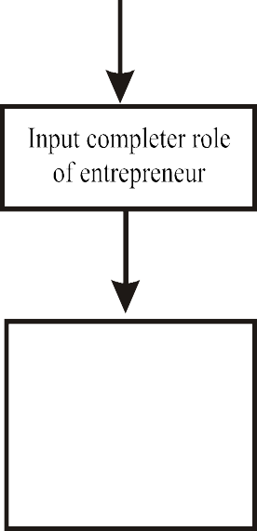
Imperfect competition/not well established market
Gap filler role of entrepreneur
Fill the gap in imperfect market to put the enterprise in motion
Transforming available inputs that improve the efficiency of the existing produ-
-ction method

Figure 2.4: Leibenstein X- efficiency Theory
The theory concludes that an entrepreneur has to act as gap filler and an input completer if there are imperfections in markets. For using there unusual skills, he gets profits as well as a variety of non-peculiar advantages. According to him there are two types of entrepreneurship.
  - Routine entrepreneurship – deals with normal business functions like co-ordinating the business activities.
  - Innovative entrepreneurship – wherein an entrepreneur is innovative in his approach. It includes the activities necessary to create an enterprise where not all the markets are well-established or clearly defined.

Risk Bearing Theory of Knight:
A key element of entrepreneurship is risk bearing. Prof. Knight and John Staurt Mill saw risk-bearing as the important function of entrepreneurs. Some important features of this theory are as follows:
- Risk creates Profit: According to the risk-bearing theory, the entrepreneur earns profits because he undertakes risks.
- More Risk More Gain: The degree of risk varies in different industries. Entrepreneurs undertake different degrees of risk according to their ability ad inclination. The risk theory proposes that the more risky the nature of business, the greater must be the profit earned by it.
- Profit as Reward and Cost: Profit is the reward of entrepreneur for assuming risks. Hence, it is also treated as a part of the normal cost of production.
- Entrepreneur’s Income is Uncertain: He identifies uncertainty with a situation where the probabilities of alterative outcomes cannot be determined either by a priori reasoning or by statistical inference. Apriori reasoning is simply irrelevant to economic situation involving a unique event. This theory summarizes that profit is the reward of an entrepreneur effort which arises for bearing non- insurable risks and uncertainties and the amount of profit earned depends upon the degree of uncertainty bearing. Knight argues that business enterprises the level of uncertainty can be reduced

through ‘consolidation’. Consolidation is to uncertainty is what insurance is to risk; it is a method of reducing total uncertainty by pooling individual instance. The elasticity of the supply of self confidence is the single most important determinant of the level of profit and the number of entrepreneurs.

Max Weber’s Theory of Entrepreneurial Growth:
Max Weber in his theory says religion has a large impact on entrepreneurial development. According to Weber some religions have basic beliefs to earn and acquire money and some have less of it. He calls them a ‘spirit of capitalism’ and ‘adventurous spirit’. The spirit of capitalism will be generated when mental attitude in the society is favourable to capitalism. According to Max Weber, driving entrepreneurial energies are generated by the adoption of exogenously-supplied religious beliefs. It is these beliefs which produce intensive exertion in occupational pursuits, the systematic ordering of means to ends, and the accumulation of assets. His theory suggests the belief systems of Hinduism, Buddhism ad Islam do not encourage entrepreneurship. His stand has been challenged by many sociologists. Max Weber’s Theory is shown in Figure 2.5
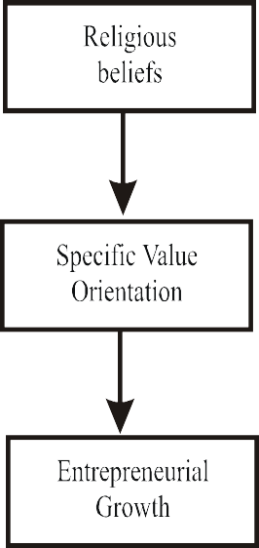

Figure 2.5: Max Weber’s Theory

Max Weber’s theory suited the colonial rulers who wanted to encourage European entrepreneurship in India. But it has been criticised by subsequent researchers. The theory is based on the invalid assumptions, which are:
  - There is a single system of Hindu value,
  - The Indian community internalised those values and translated them to day-to-day behaviour, and
  - These values remained immune to and insulated against external pressures and change. The rapid growth of ­entrepreneurship in India since independence proves that Hinduism is not averse to the spirit of capitalism and to adventurous spirit.
Many thinkers have accepted the Weber’s analysis of linkage between religious belief and entrepreneurial growth. But this view is not accepted universally. Samuelson criticised Weber’s view on the ground that capitalism also developed in those societies where protestant ethic was ‘not prevalent. Hoselitz argued that Protestant could not develop industries in France because they were not given political security. It can be concluded in the words of Carroll that “ethical values have some effect on entrepreneurial growth but to consider them all in all would be unrealistic.”

Hagen’s Theory of Entrepreneurship:
One important theory of entrepreneurial behaviour has been propounded by Hagen which is referred to as the withdrawal of status respect. Hagen has attributed the withdrawal of status respect of a group to genesis of entrepreneurship. Hagen considers the withdrawal of status, of respect, as the trigger mechanism for changes in personality formation. Status withdrawal occurs when members of some social group perceive that their purposes and values in life are not respected by the groups in the society they respect, and whose esteem they value. Hagen postulates four types of events which can produce status withdrawal:
- Displacement of a traditional elite group fromits previous status by another traditional supply physical force.
- Denigration of valued symbols through some change in the attitude of the superior group.
- Inconsistency of status symbols with a changing’ distribution of economic power.
- Non-acceptance of expected status on migration to a new society.
Hagen further postulates that withdrawal of status respect would give to four possible reactions and create four different personality types:
  - Retreatist: Entrepreneur who continues to work in society but remains indifferent to his work or status.
  - Ritualist: One who works as per the norms in the society hut with no hope of improvement in the working conditions or his status.
  - Reformist: One who is a rebellion and tries to bring in new ways of working and new society.
  - Innovator: An entrepreneur who is creative and try to achieve his goals set by himself.
According to Hagen (1962), the creativity of a disadvantaged minority group is the main source of entrepreneurship. He developed this thesis from the case of the samurai community of Japan. Traditionally, this community had enjoyed a high status of which it was deprived later. To regain this lost prestige, it became more active and vigorous and gave rise to many entrepreneurs. McClelland supported this thesis by admitting that a suppressed community had more creativity. He said that Jains could be successful entrepreneurs because of their consciousness of their majority and superiority complexes. McClelland had modified Hagen’s thesis slightly in order to explain such cases. He stated that the subordination of minority group could arouse achievement motivation in its members but its extent depended upon the initial level of motivation and the means available to the group to active its achievement motivations.

Thomas Cochran’s Theory of Cultural Values
The key proportions in Thomas Cochran’s theory are cultural values, role expectations and social sanctions. According to him, the entrepreneur represents society’s model personality. His performance is influenced by the factors of his own attitudes towards his occupation, the role expectations held by sanctioning groups, and the operational requirements of the job. The determinants for the first two factors are the society’s values. Changes over time in such variables as population, technology, and institutional drift will impinge on the role structure by creating new operational needs. In most countries, entrepreneurs have emerged from a particular socio-economic class. The Protestant ethic of the West is said to have contributed to the emergence of a new class of industrialists. It can be noted that various communities and castes like samurai in Japan, family pattern in France, Yoruba in Nigeria, Kikuya in Kenya, Christians in Lebanon, Halai Memon industrialists in Pakistan, Parsees, Marwaries and Gujaratis in India have been the sources of entrepreneurship.

Theory of Change in Group Level Pattern:
Young defines entrepreneurs as that the entrepreneur characteristics are found in small groups wherein individuals develop as entrepreneurs. Young arrived at the group level pattern behaviour entrepreneurs based on his studies known as Thematic Appreciation Test (TAT) on groups of entrepreneurs. The test revealed’ the tendency to describe the situation as a problem to be solved, an awareness of pragmatic effort required, confidence in their own ability to solve the problem and a tendency to take the viewpoint of each individual in turn and analyse the situation as he might see it before suggesting an outcome. Young’s theory is a theory of change based on society’s incorporation of reactive subgroups. A group becomes reactive when the following three conditions coincide:
- When denied of access to important social networks;
- When a group experiences low ‘status recognition; and
- When the group has better institutional resources than other groups in the society at the same level.

Economic Theory of Entrepreneurship
Many economists revealed that entrepreneurship and economic growth will take place in those circumstances where particular economic conditions are in favour of the business environment. The main advocates of this theory were Papanek and Harris. According to them economic incentives are the main forces for entrepreneurial activities in any country. There are a lot of economic factors which promote or demote entrepreneurship in a country. These factors are:
  - The availability of bank credit
  - High capital formation with a good flow of savings and investments
  - Supply for loanable funds with a lower rate of interest.
  - Increased demand for consumer goods ad services
  - Availability of productive resources.
  - Efficient economic policies like fiscal ad monetary policies
  - Communication and transportation facilities
Economic development was the result of rationalization of technology and accounting systems and the acquisition of capital and its productive use was the main theme of the Weberian thesis. Some scholars have tried to explain the growth of entrepreneurship in terms of regional economic factors, e.i., industrial support to environment in these regions. Aquestion which was analysed by a researcher is: “Since Jains andVaisyas were in every corner of India, why was it that only Marwari ad Gujarati Vaisyas and Jains gave lead in entrepreneurship, mostly in Gujarat”. This analysis revealed that Gujarat had environment favourable to business and industry. Thus, it can be concluded that the industrial climate may have a very significant impact on the response of entrepreneurs. However, the group factors, as emphasized by various studies, cannot be ignored altogether.

Exposure Theory of Entrepreneurship:
Many studies have shown that it is the exposure to new ideas and opportunities towards creativity ad innovation which leads to create a new venture. There is adequate empirical evidence to prove its validity. ‘Tripathi has observed that exposure to new ideas and values were the common factor between Parsi and Hindu entrepreneurs, which led them to entrepreneurship. Education have played very significant role in exposing the Indian entrepreneurs to Western ideas leading them to entrepreneurship. It is also the differential responses of the social groups to opportunities provided by the commitment of the political system to industrialisation that has led the process of entrepreneurial spread. This concept is illustrated inFigure 2.6 as under:

Risk bearing capacity
Religious belief
Need for achievement
Motivation
Economic factors
Cultural Values

Entrepreneur
Education
Exposure Towards
- New idea and opportunities
- creativity and innovation
New venture Creation

Figure 2.6 : Exposure Theory of Entrepreneurship
- Political System Theory of Entrepreneurial Growth:
Political system can crate adequate infrastructure, favourable laws, favourable taxation system andprocedures, provide incentives and subsides, security to entrepreneurs, create promoting policies and can encourage people towards entrepreneurship. Government can also build supporting system for potential entrepreneurs. Thus, the commitment of political system can contribute significantly towards entrepreneurial development.

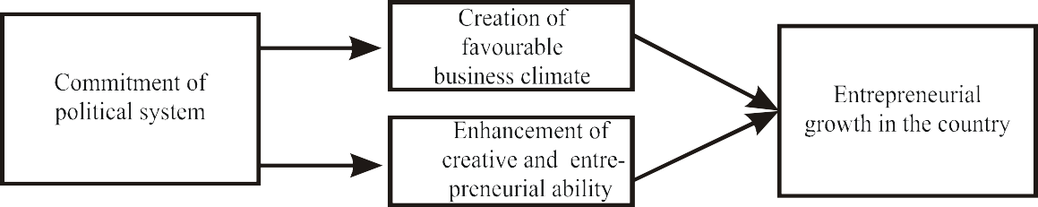

Figure 2.7: Political System Theory of Entrepreneurial Growth

According to Hoselitz, Japanese entrepreneurs could flourish because their political system was able to properly integrate with various sectors such as the industrial and agricultural, large, small and handicraft industries, labour intensive and capital intensive technology, traditional and modem social structure. Also, there was no colonial disruption. According to Boulding “political structure was the decisive factor in entrepreneurial growth of France and Russia. But before 1917 it did not flourish because the creative ability of masses could not find expression. Hoselitz argued that France lagged behind entrepreneurially, because his political system did not provide sufficient incentives and security to entrepreneurs.

Factors Influencing Entrepreneurship¶
Entrepreneurship is shaped by diverse factors that can either encourage or impede the development of new ventures. Here's a summary of the main influences:

1. Economic Factors¶
- Access to Capital: Essential for startup funding, expansion, and operations.
- Market Conditions: Determines the demand for new products or services.
- Taxation and Regulation: Can either stimulate or constrain entrepreneurial activities.

2. Social and Cultural Factors¶
- Cultural Attitudes: Societal views on entrepreneurship, risk, and failure.
- Networking and Social Capital: Importance of connections and relationships in business success.
- Education and Training: Availability of entrepreneurial education and skill development programs.

3. Technological Factors¶
- Technological Advancements: Opportunities created by new tech innovations.
- Digital Infrastructure: The role of internet and digital tools in modern business.

4. Political and Legal Factors¶
- Government Policies: Influence of subsidies, grants, and regulations.
- Legal Framework: Impact of business registration processes, intellectual property rights, and legal protections.

5. Psychological Factors¶
- Motivation: Drive and ambition to start and grow a business.
- Risk Tolerance: Willingness to embrace uncertainty and potential failure.

6. Environmental Factors¶
- Sustainability Concerns: Opportunities in green tech and sustainable business practices.
- Globalization: Effects of global economic trends on entrepreneurship.

7. Demographic Factors¶
- Age and Gender: Influence of demographic trends on entrepreneurial activity.
- Migration: Contribution of diverse perspectives to the entrepreneurial ecosystem.
Recognizing these factors is crucial for anyone involved in the entrepreneurial ecosystem, including entrepreneurs, policy makers, and educators, to create supportive environments for business innovation and growth.

External factors affecting the business meaning
There are two types of factors influencing business decisions: internal and external. Internal factors are elements that come from within or are under a company's control, e.g. human resources, organisational structure, corporate culture, etc. External factors, on the other hand, are elements that come from outside, e.g. competition, new technology, and government policies.
External factors are elements from outside the company that affect business performance, such as competition, economic climate, political and legal environment, technological advances, or major global events.

Thanks to this ad, StudySmarter remains free.Sign up for a free account to access a better learning experience.

External factors affecting business
There are five main types of external factors affecting business:
- Political
- Economic
- Social
- Technological
- Environmental
- Competitive.
Use the acronym PESTEC to memorise this better!
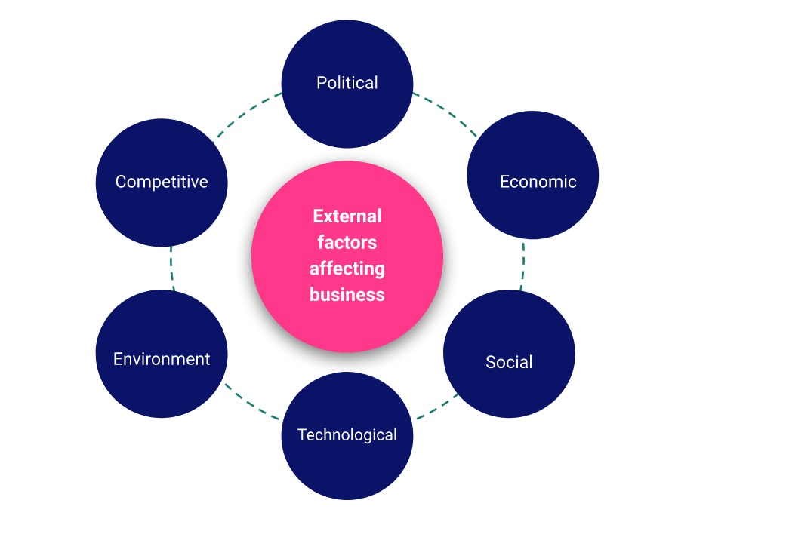

Figure 1. Business External Factors - StudySmarter
External factors can have both positive and negative impacts on business operations. To sustain profitable growth, companies need to constantly monitor environmental changes to adapt and minimise their negative consequences.

Political factors affecting business
Political influence on business refers to new legislation that affects consumers', employees, and businesses' rights.
Some examples of business-related legislation include:
- Anti-discrimination
- Intellectual property
- Minimum wage
- Health and safety
- Competition
- Consumer protection.
Generally, these are grouped into three categories:
- Consumer laws - These are laws that ensure businesses will provide consumers with quality goods and services.
- Employment laws - These are laws that protect employee rights and regulate the relationship between employees and consumers.
- Intellectual property law - These are laws that protect creative work within the business world, e.g. copyrights of music, books, films, and software.
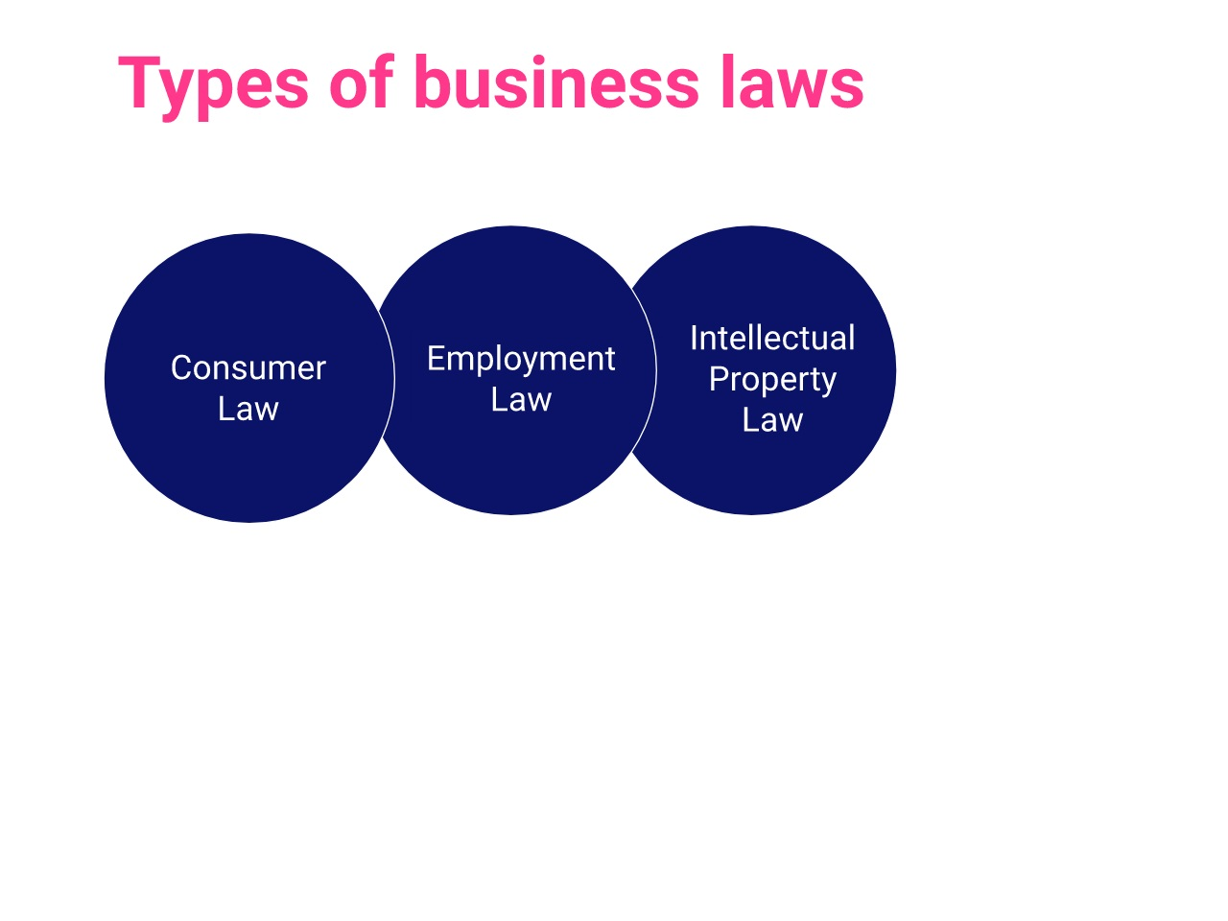

Economic factors affecting business
Businesses and the economy have a mutual relationship. The success of businesses results in a healthier economy, whereas a strong economy allows businesses to grow faster. Thus, any changes in the economy will have a significant impact on business development.
Economic activities can deeply be affected by changes in:
- Tax rates
- Unemployment
- Interest rates
- Inflation.
One measure of economic performance is aggregate demand. Aggregate demand is the total demand for goods and services within an economy (including consumer and government spending, investing, and exports, minus imports). The higher the aggregate demand, the more robust an economy is. However, too much demand can lead to high inflation, resulting in higher prices for consumers.
Changes in tax, interest rates, and inflation can result in a rise or fall in aggregate demand, which affects economic activity. For example, with lower taxes, individuals and households have more income at their disposal to spend on goods and services. This contributes to higher demand, resulting in more production and jobs created. As a result, business activities grow and the economy flourishes.

Social factors affecting business
Social factors affecting business refer to changes in consumer tastes, behaviour, or attitude that might affect business sales and revenues. For example, nowadays, consumers are paying more attention to environmental issues such as climate change and pollution. This puts pressure on firms to adopt eco-friendly solutions to their production and waste disposal.
Social influence also includes the ethical side of a business, such as how a company treats its employees, consumers, and suppliers.
An ethical business is one that considers the needs of all shareholders, not just owners. Typically, business ethics comprise three main aspects:
- Employees - Ensure work-life balance as well as the physical and emotional well-being of the employees.
- Suppliers - Stick to the agreed contract and pay suppliers in a timely fashion.
- Customers - Provide quality products at a fair price. Businesses should not lie to consumers or sell products that do serious harm to consumers.
In a perfect world, companies would comply with all ethical policies and contribute to the betterment of society. However, in reality, this is unlikely to happen, as ethics tend to be at the opposite end of profitability. For example, a company that paid everyone a living wage might end up with lower profits.

Technological factors affecting business
Technology is used extensively in modern business, from production to product selling and customer support. Technology allows a company to save time and labour costs while achieving more efficiency, which, in the long run, can result in a competitive advantage.
Three key areas of technology in business are automation, e-commerce, and digital media.
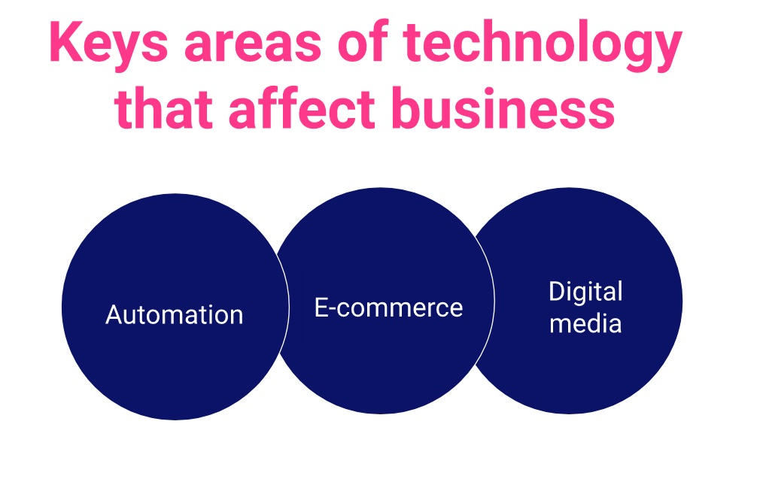

Figure 3. Areas of technology that impact business
Automation is the use of robots to perform repetitive tasks formerly done by humans.
Automation is applied throughout the supply chain of many industries, including electronics manufacturing, automotive, retail, online services, banks, etc.
The manufacturing of cars and trucks is carried out by big, automated robots instead of human workers. These robots can perform a wide range of tasks including welding, assembling, and painting. With automation, production becomes safer, more efficient and more accurate. Companies can hire fewer workers for menial work and focus more on quality-improving activities.
In addition to automation, there is a trend towards e-commerce.
E-commerce is the buying and selling of goods and services on the internet.
Many companies set up an e-commerce shop to accompany their brick-and-mortar stores, while others operate 100% online.
Some examples of e-commerce include:
- An online bookstore
- Buying and selling through Amazon or eBay
- An online retailer.
The key incentive for businesses to move online is to reduce fixed costs. While physical businesses have to pay healthy monthly fees for rent, warehousing, and electricity on-site, an online business pays little to no fixed costs.
For example, an Etsy shop selling cooking recipes and printables can avoid costs of warehousing, hiring workers to work on-site, and renting out a location. Without the burden of fixed costs, the business owner can focus more on product development and promotion.
Finally, there is the extensive use of digital media.
Digital media are online channels that get businesses in contact with their customers.
Some examples include websites, blogs, videos, Google ads, Facebook ads, emails, social media, etc.
While traditional marketing methods like billboards and banners are restricted to local areas, online channels allow companies to communicate their marketing messages across the globe in a matter of seconds.

Environmental factors affecting business
Environmental influence refers to changes in the natural world, such as weather conditions, that might affect business operations.
The production of goods and services is the major cause of climate change, pollution, and waste. For example, the generation of electricity in coal-fired plants releases a tremendous amount of carbon dioxide into the atmosphere, which causes global warming and acid rain. The fashion industry is another CO2 emitter, contributing to around 8-10% of the total greenhouse gas emission each year.
The good news is that many companies nowadays have been adopting eco-friendly solutions to mitigate their impacts on the environment. Some examples include:
- Recycling packaging
- Offsetting carbon footprint
- Introducing energy-saving plans
- Adopting more energy-efficient equipment
- Switching to fair-trade suppliers.

Competitive factors affecting business
Competitive influence refers to the impact of competition in the business environment. The impact can come from changes in price, product, or business strategy. For example, if a company selling similar products at a similar price to your business suddenly drops its price to attract more customers, you may have to reduce the price as well or risk losing customers.
To avoid the impact of competitive influence, a company can develop competitive advantages. These are attributes that allow the company to outperform its rivals. A business can gain a competitive advantage by investing in a high-quality labour force, exceptional customer support, stellar products, extra services, or a reputable brand image.
The competitive advantage of Starbucks is that it is a global company with strong brand recognition, premium product quality, and a cosy environment that makes customers feel at home. Starbucks is not only a coffee store but a place where you hang out and have a good time with friends and family.

How do changes in the external environment affect business?
In the modern world, external factors are changing at a rapid rate, causing competition to become more intense than ever. Businesses that underestimate competition or are too slow to adapt will get replaced by more innovative firms.
Changes in the external environment are often caused by:
- A shift in consumer behaviour
- Introduction of new technology
- Entry of new competition
- An unpredictable event such as war, economic crisis, global pandemic, etc.
- Adoption of new legislation, e.g. tax policy, minimum wage.
Before 2007, the world was oblivious to the 'swipe and touch' device, as the mobile phone industry was dominated by Nokia. The introduction of touch screens by Apple changed all of this. Nowadays, most people own a smartphone and spend countless hours communicating, working, and entertaining via their mobile devices. The increased mobile usage also forces companies to adapt sales and marketing tactics to be more mobile-friendly.
Changes in the external environment bring both opportunities and challenges for businesses.
For example, the emergence of online marketing channels such as Facebook and Google ads allows businesses to market and sell their products more effectively. However, their competitors will also have access to the exact same tools and customer base.
To gain a competitive advantage, businesses cannot rely solely on external technology. They need to invest in their own assets such as internal databases, human resources, and intellectual property.
Another way to gain this advantage is to become more socially responsible.
Corporate Social Responsibility (CSR) refers to the positive contribution of a company to the environment, economy, and community.
With the external environment changing and the business landscape being taken over by technology, businesses stand a better chance if they are seen in a positive light. This does not mean companies should put on a show. Instead, they should put in a genuine effort to better society.
Some CSR activities include reducing carbon footprint, allocating part of the profit to developing economies, purchasing eco-friendly materials, and improving labour policies.
Starbucks's CSR: Starbucks aims to create a positive impact on the communities it works with by partnering with local non-profit organisations. For each partner, Starbucks donates $0.05 to $0.15 per transaction. The company also provides jobs for veterans and military workers while emphasising diversity and inclusion in the workplace.
As you can see, there are many external factors influencing businesses operations, including globalisation, technological, ethical, environmental, economic, and legal influences. These factors are changing all the time, and to survive, businesses must adapt and react to these changes. Failing to do so will put them at the risk of losing customers and closing down.

External factors affecting business decisions - Key takeaways
- External factors are factors from outside that affect a business's performance, such as economic climate, political and legal environment or technological advances.
- There are five main types of external factors affecting business:
  - Political factors
  - Economic factors
  - Social factors
  - Technological factors
  - Environmental factors
  - Competitive factors.
- External factors are changing the business landscape at an accelerating rate, and companies that fail to keep up will end up getting replaced by others.
- To manage changes in the external environment more efficiently, companies should invest in their internal resources and corporate social responsibility (CSR).

(Symptoms)Reason and Remedies for 13 Common Entrepreneurial Pitfalls
It seems that everyone on Instagram is an Entrepreneur or CEO. What used to be a high risk and scary choice, has now been glamorized into fast money, luxurious lifestyles, and ready-set-go businesses.
A picture is worth a thousand words, but the stories behind the glossy pictures are anything but fancy. I know the true stories of self-doubt, self-sabotage, and business burnout.
Over the years I’ve seen the same 13 challenges and entrepreneurial pitfalls in myself, my clients, and other entrepreneurs:
- Not Having a Clear Focus/Mission
- Trying to Be All Things to All People
- Lack of Revenue Diversity — Relying on One Client
- Imposter Syndrome
- DIYitis
- Isolation
- Burning the Candle at Both Ends/Lack of Self-care
- Taking it Personal and Not Making it About the Client/Customer
- Not Going All In/ Not Showing Up at 100%
- Not Charging the Appropriate Amount (usually too little)
- Investing in Tactics and Not Youself or Business
- Not Taking/Accepting Help
- Expecting Success to Come Easy with Minimal Effort
But how do we overcome these challenges and entrepreneurial pitfalls?
We start a new conversation.
We get honest
We get real and we get to the root of the issue.
Simple right? Now go do it!
It would be unfair to leave you with a list and a simple three-sentence plan.
In the next section, we’re going to dive into the source, symptoms, and remedy for each pitfall. Before we get going, I suggest writing down, the numbers of your pitfalls. Don’t be afraid… I deal with and have dealt with all 13!

1. Not Having a Clear Focus/Mission
Source: Information overload. The entrepreneur starts with an initial excitement and idea to follow and then, like Pac Man, starts gobbling up all the ideas. With a lack of organization and filtration device, the ideas get muddied. What once started as vibrant colors and ideas have now mixed into a glob of muck.
Symptoms: Squirrely focus. Distracted easily. Persuaded easily by others. Overwhelmed. Frustrated. Frazzled. “Yes” to all the things.
Remedy: Stop. It’s time to go back to square one before the business was ever in motion. What was the core idea or inspiration? What about it excited and motivated you? This is where your new mission and focus will be developed. If you are still unclear, reach out to trusted advisors or a business coach for clarity. This will be uncomfortable at the start but stick with it until you feel a focused energy.

2. Trying to Be All Things to All People
Source: People pleasing tendencies. Not wanting to disappoint people by saying no. Desire to be “The Nice Girl or Guy.” Seeking of Likeability.
Symptoms: Burnout. Overloaded schedule. Triple bookings. Feeling of being taken advantage of. Plays roles that don’t suit skillset. Feeling of being helpful, but helpless. May suffer from reoccurring colds or illness.
Remedy: The Triple D Method to Time Management. All decisions will be based on the following three criteria:
- Doability: Can it be done with the current resources (time, skill, and manpower) as requested? If no, see “Delegatability.” If yes, see “Desirability.”
- Desirability: Does this feel like a treat or punishment? If it’s a treat, get it done! If it’s a punishment, see “Delegability” or use the power of “No.”
- Delegatability: Can this task realistically be performed by someone other than you? If yes, delegate away. If no, and it failed the “Desirability” and “Doability,” that’s a “Triple D Fail.”
You are only to say yes if it’s a “Triple D Success.”

3. Lack of Revenue Diversity — Relying on One Client
Source: Security. High Levels of Trust. Single Focus.
Symptoms: Scarcity mentality. Anxiety around outside factor. Worry around when the well will dry up. All or nothing mentality. Increased stress. Lack of sleep. Weight gain/Weight loss related to stress.
Remedy: Business Development. Who are the next 3-5 organizations/clients that would benefit from your services? It’s time to pick up the phone or write some emails. If a client is responsible for more than 40% of your revenue, it’s time to diversify. It’s easier to make up 40% than 100%.

4. Imposter Syndrome
Source: Lack of confidence. Self-doubt. Limiting beliefs around being qualified/verified. Past examples of failure, being unsure, witnessing failure in others.
Symptoms: Self-sabotage. Not showing up as an expert or thought leader. Playing small. Selling self-short.
Remedy: Create Your Credentials. Just like in school you had to pass a core curriculum, now is your chance. Write down a list of the credentials you need to be a qualified entrepreneur. Seriously. Don’t make it about anyone else. What do you need to learn, experience, gain expertise in, connect to? Create a 101, 201, 301 and 401 syllabi and go from there. After you’ve accomplished your course load, you get to graduate! Yes, you need a ceremony, cap, gown, and diploma!

5. DIYitis
Source: Lack of trust. Past disappointment. My-way-is-the-only-way mindset.
Symptoms: Overwhelm. Overload. Burnout. Distrust. Micromanaging others. Taking back control after delegating. Not outsourcing when appropriate. Slowing down progress. Project stall out.
Remedy: Recruit a Trusted Partner. Whether it’s a colleague or coach, you need someone who has your back and will give you honest feedback and input. You can’t do it all and you shouldn’t have to. What do you need support with? What can you easily move off your plate? Start small and work to build trust with others. If you assume everyone will burn you, you’re probably attracting in people who will. What if you could set your sites on someone who will be truthful and direct with you? Even if you don’t like what they have to say, at least you know where they stand. And how awesome would it be to move things off your plate and focus on your strengths?!

6. Isolation
Source: Fear of rejection. Desire to focus inwards. Introversion.
Symptoms: Refuses social invitations. Lack of networking and connection with others. (See DIYitis). Rejection of idea sharing and brainstorming.
Remedy: Exposure. Sign up for a Meet-Up group or networking event. Call a friend or two. Meet a colleague or client for coffee. Get a shower, get dressed and get out there. Your home office funk is seeping into your pores, it’s time to fresh up your body, mind, and brain!

7. Burning the Candle at Both Ends and Lack of Self-care
Source: Assumption of Machine-Like Abilities. False Sense of Unlimited Energy.
Symptoms: At its most extreme level, illness and burnout. Initially, it is shown as an unstoppable force. Others envy their unstoppable abilities that seem like the Energizer Bunny. For outsiders, they keep going and going without sleep. Without the necessary care and recharge, they undoubtedly crash.
Remedy: Sleep (7 hours+), Meditation (5-10 minutes per day), Walking outdoors, Yoga, Nutritious food. If you’re familiar with Maslow’s hierarchy of needs, these are at the foundation. If you want to run efficiently like a machine, you’ve gotta keep it fueled and serviced.

8. Taking it Personal and Not Making it About the Client
Source: Fear of being wrong. Fear of failure. Scarcity mentality. Over-personification with business.
Symptoms: By only focusing on one opinion, the entrepreneur is either all right or all wrong. There is no gray area. With a personal single focus, decisions are made on emotional impulse and reaction. Feelings of disconnection and rejection. Internalization of rejection. Judgment. Energy sinks with each rejection.
Remedy: Objectification. You are not the business and the business is not you. Your business is your product/service for clients/customers. By focusing on the needs of those purchasing your goods and services, you can make comprehensive, data-driven and objective decisions. Each failure and success may be a result of your decision, but it does not define who you are.

9. Not Going All In or Not Showing Up at 100%
Source: (See Imposter Syndrome) Lack of confidence. Fear of failure. Fear of success.
Symptoms: Hesitation. Underselling expertise. Lack of risk-taking. Unconfident body language. Fidgeting and lack of focus in conversation.
Remedy: (See Imposter Syndrome Remedies) Get to Your Why. It goes back to your why? Why are you an entrepreneur? Why are you taking some safe risks, but not the necessary ones to grow? What are you really afraid of?

10. Not Charging the Appropriate Amount
Source: Fear of rejection. Getting into Client’s Story. Assumption of Value. Interpretation of Lower Value. Lack of Confidence.
Symptoms: Stating prices and then quoting lower. Assuming the client doesn’t want to or can’t pay prices. Afraid of people saying no. Consistently take money off of the table before the negotiation has begun. Acknowledges they could be making more, but find it hard to ask.
Remedy: Set Your Prices, Value, and Rationale. This is where you let the facts run the show. Do your research, how much are your competitors charging and what is an appropriate rate? What value do you bring to the table (see your credibility exercise in Imposter Syndrome)? Now write down your rationale for each price. This is your new internal and external script. Until you know it by heart and believe it, you depend on it.

11. Investing in Tactics and Not Yourself or Business
Source: Belief in the Magical Pill. Immediate Gratification. Avoidance of Discomfort. Lack of Focus or a Plan.
Symptoms: Multiple purchases of “Get Rich Quick” or “Learn this Tactic” program, but fails to full implement or see results. Thousands of dollars have been spent, but not invested. Uses language like “If only I…” or “When this gets done, then I’ll be successful.” Frustration at lack of results. Blames others for lack of success.
Remedy: The Mirror. What is it that you’re avoiding that you’ve been needing to do in your business? What are you not taking care of within yourself or relationships? The issues we see in our business are a direct reflection of what we’re not managing internally. Take a deep hard look in the mirror and start asking for help.

12. Not Taking or Accepting Help
Source: (See DIYitis) Lack of trust. Fear of burdening others. Fear of disappointing others.
Symptoms: Overwhelmed. Low energy. Dejected. Feeling like a failure.
Remedy: Stock Your Shelves. Just like in a supermarket, you’re going to do an inventory check. What are you feeling low or out of supply in? Motivation, support, a hug? Note what you need and then look at your supplies. Who around you can support you in restocking your shelves? Reach out and ask for exactly what you need. I guarantee you’ve got a long line of people ready to help you!

13. Expecting Success to Come Easy with Minimal Effort
Source: Instagram-Insta-Success Stories. Comparison. Instant Gratification.
Symptoms: Lack of patience. Frustration at delays. Anger. Dejectedness. Impulsive decision making. Quick-fix program purchases.
Remedy: Build Your Blueprint. What does success look like for you? How long will it really take to get there? What resources do you need to support it? What daily, weekly, monthly tasks do you need to support it? What’s your contingency plan if it doesn’t work out?

